**MAPPING DATA ONTO AESTHETICS**

Mapping data onto aesthetics involves using design principles, visual elements, and creative techniques to effectively communicate information through visual representations. This is commonly done in data visualization, graphic design, and art. Here are some examples of mapping data onto aesthetics:

**Bar Chart**

- Aesthetic Choices: Use of different colors, varying bar heights, and spacing.

- Example: A bar chart representing monthly sales data for a year, where each month is color-coded differently for easy distinction, and the bars are scaled to represent the sales values.

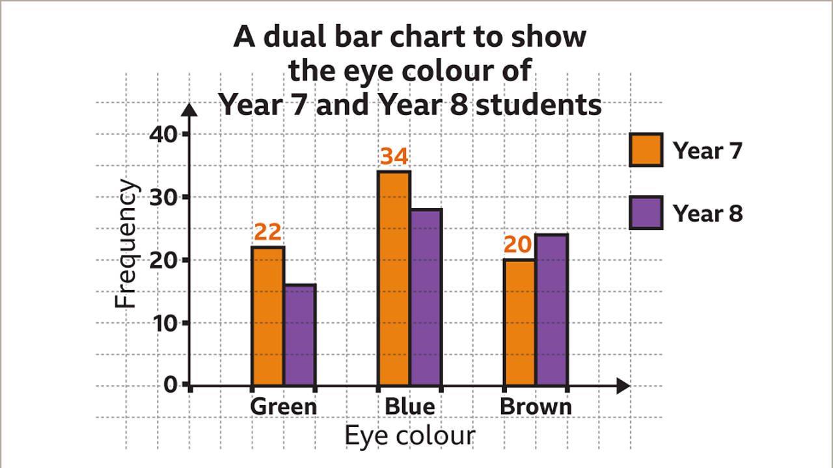

**Heatmap**

- Aesthetic Choices: Color gradients, cell size, and arrangement.

- Example: A heatmap illustrating website traffic by time of day and day of the week. Darker colors represent higher traffic times, and the cells are organized in a calendar grid.

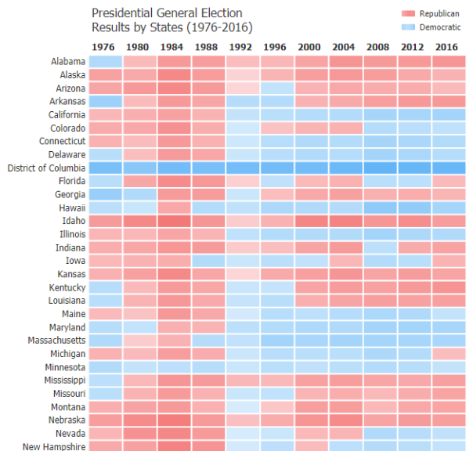

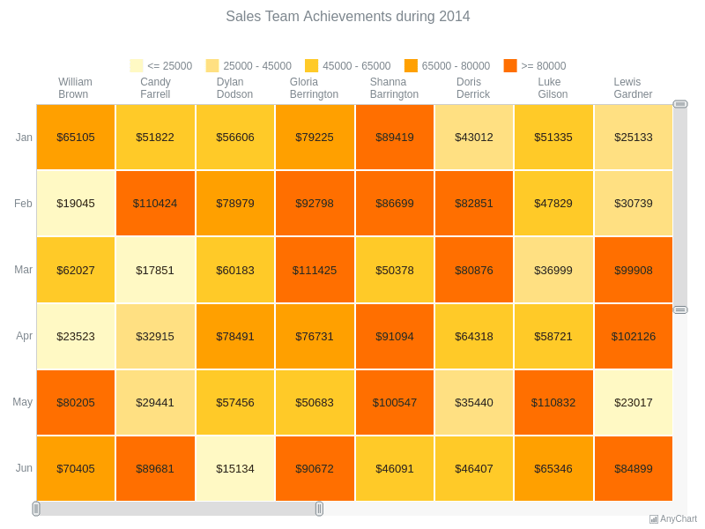

**Scatter Plot**

- Aesthetic Choices: Markers (e.g., circles, squares), color, and axis labels.

- Example: A scatter plot showing the relationship between the price and size of houses in a neighborhood. Larger circles represent bigger houses, and color might indicate the year they were built.

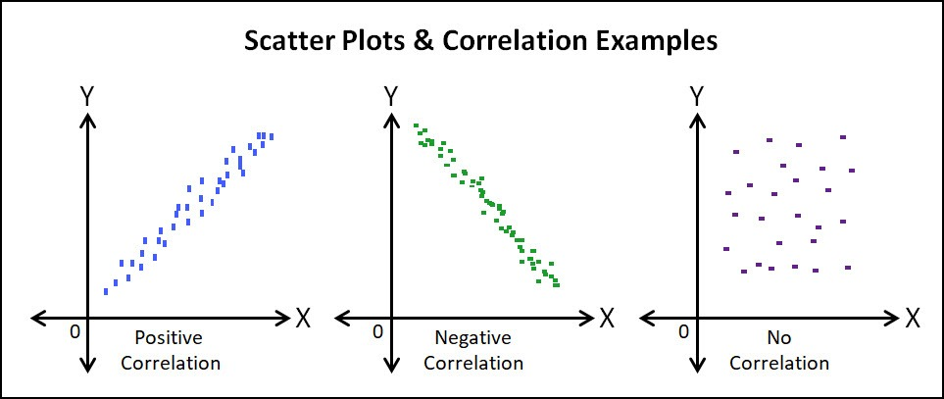

**Tree Map**

- Aesthetic Choices: Nested rectangles and colors.

- Example: A treemap visualizing a company's budget allocation, with each department represented as a colored rectangle. The size of the rectangle corresponds to the budget, and smaller rectangles within it represent subcategories.

Introduction

In this article, we will explore one such chart called ‘Treemap’ for categorical visualization with different ways to build the same chart in Python and a step-by-step tutorial for each option.

**What is a Treemap?**

A treemap is a special type of chart for visualization using a set of nested rectangles of categorical data that is preferably hierarchical. Treemaps were first used in the 1990s by Professor Ben Shneiderman at the University of Maryland.

In Hierarchical data, the categories or items share parent-child type relationships in an overall tree structure. The simplest example of this type of data structure can be seen in a company where all individuals and their designations within teams could be grouped under one entity i.e., the company itself. However, sometimes, treemaps can also be used with non-hierarchical data. A few examples of these have been mentioned later in this article.

**When to use a Treemap?**

These are some key points to consider before using treemaps for visualization.

– Treemaps work well when there is a clear ‘Part-to-whole’ relationship amongst multiple categories present in the data.

– Hierarchical Data is needed. This indicates that the data could be arranged in branches and sub-branches. These can then be visualized using rectangles of different dimensions and using more than one color. All this is based on calculated values from the proportions of the quantitative variables.

– The focus is not on precise comparisons between categories but rather on spotting the key factors/trends or patterns.

**Benefits of using a Treemap**

Treemaps offer some interesting advantages over the regular pie charts and bar charts in certain situations like –

– **Space constraint:**There is a large amount of hierarchical data that needs to be visualized in a smaller space.

– **Easier to read:** When compared to a circular multi-level pie chart, the treemap is easier to read due to its linear visual appearance.

– **Quickly spot patterns:**Since each group is represented by a rectangle and the area of this rectangle is always proportional to its value, trends and patterns (similarities and anomalies) are quickly visible in treemaps.

**Few Real-world use cases for Treemap Charts**

The treemap chart can be used in different industries but some general use cases (please note all these examples use dummy data to demonstrate the chart applicability) are mentioned below.

**1. Displaying region-wise customer complaints about a product**

Suppose there are 10 different types of complaints (assume these are denoted as C1 to C10) about a product and the company wants to visualize which complaints are relevant to a region then in such a case a treemap could be used as shown below. Here, it can be clearly seen how different regions have specific types of user complaints.



**2. Showcasing category-wise product availability like mobile phones**

Let us assume that there are four categories of mobile phones with their market share percentages i.e., Low-end (up to 10,000 INR – 15%), Mid-Range (10,000-25000 INR- 55%), Premium (above 25,000 to 50,000 INR-25%), and Top-end (above 50,000 INR-10%). From this treemap, we can gauge that there is a bigger demand and market for Mid-Range phones while there are limited phones available in the Top-End category.



**3. Explore customer segmentation for a product**

Usually, companies for apparel or personal products divide their customers based on their age. This way they can categorize their products and the product variants separately for each age group. In the case of this treemap, the company could decide whether to launch more products for particular customer segments based on the distribution.



**6. Word Cloud**

- Aesthetic Choices: Font size, color, and arrangement of words.

- Example: A word cloud summarizing customer reviews for a product, where frequently mentioned words are displayed in larger fonts and positive words are in green while negative words are in red.

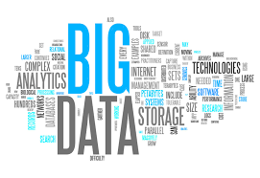

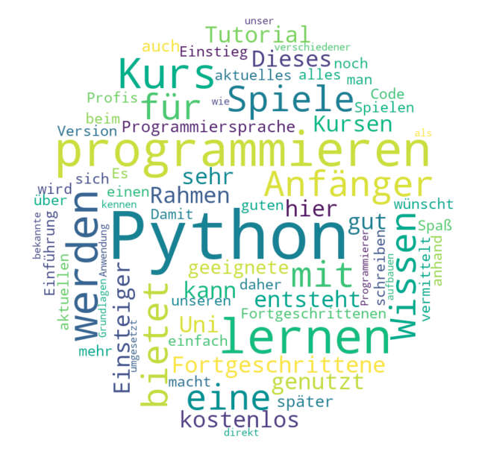

**7. Network Diagram**

- Aesthetic Choices: Node and edge styles, color, and layout.

- Example: A network diagram showing social connections on a professional platform. People are represented as nodes, and connections as lines, with color indicating different industries.

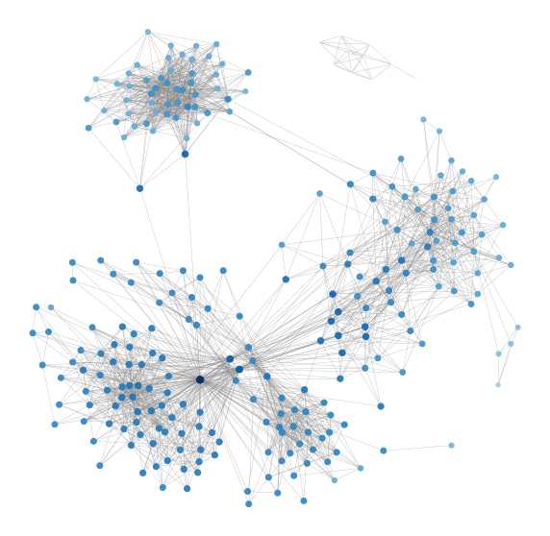

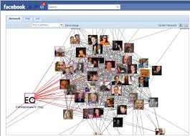

**8. Choropleth Map**

- Aesthetic Choices: Color scheme, legend, and data classification method.

- Example: A choropleth map illustrating population density in U.S. states. Darker shades represent higher population densities, and a well-designed legend explains the color scale.

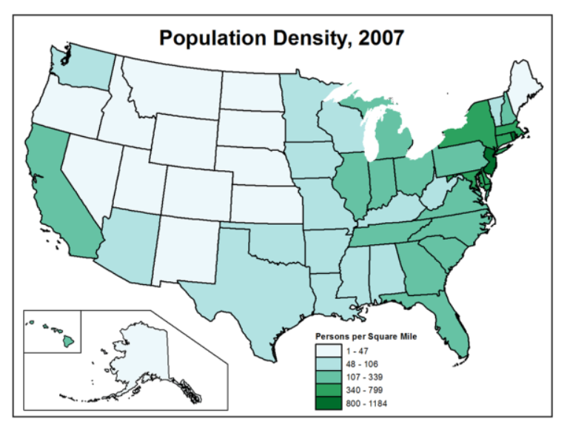

**9. Time Series Chart**

- Aesthetic Choices: Line style, markers, and labeling.

- Example: A time series chart tracking stock prices over a year. The line graph uses a smooth curve to connect data points, with markers at key events and dates labeled on the x-axis.

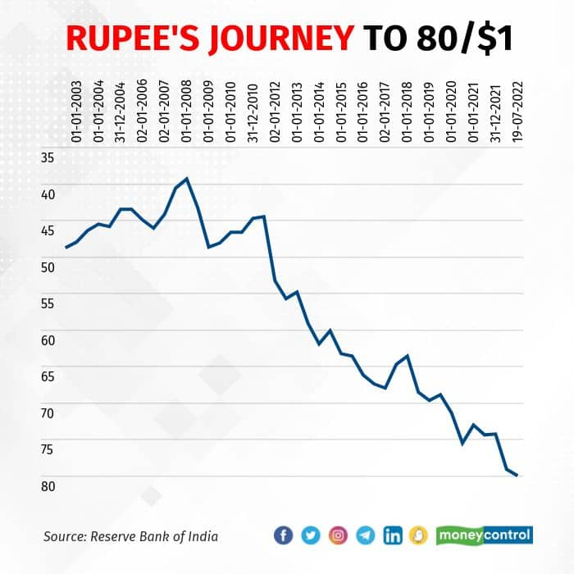

**10. Pie Chart**

- Aesthetic Choices: Slice colors, labels, and shadows.

- Example: A pie chart representing the distribution of expenses in a household budget. Each expense category is a colored slice, and labels are placed near their respective slices for clarity.

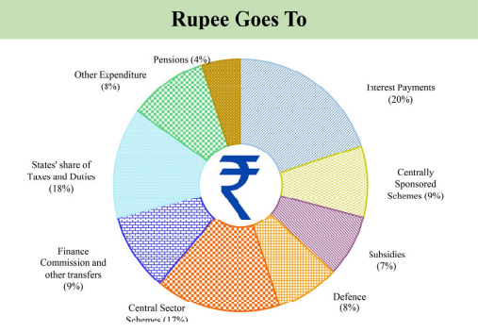

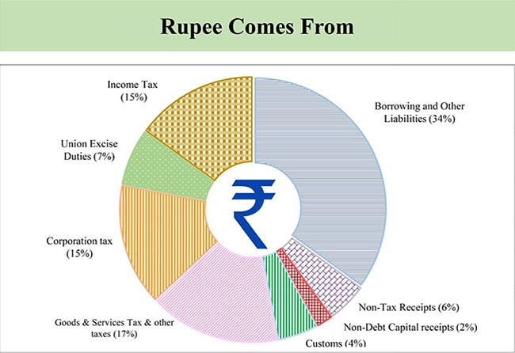

In all these examples, the aesthetics serve to make the data visually appealing, understandable, and memorable, thus enhancing the communication of information. The specific choices made will depend on the data being presented and the audience's needs and preferences.

**AESTHETICS AND TYPES OF DATA**

Aesthetics in the context of data refers to the visual and perceptual design choices made when presenting data to make it more appealing, understandable, and effective in conveying information. A well-designed data visualization can enhance the comprehension of complex data sets. There are various types of data, and different aesthetics may be more suitable for each type. Here are some common types of data and examples of aesthetics associated with them:

**1. Categorical Data**

- **Bar Charts:** Aesthetically pleasing bar charts can use vibrant colors and clear labels to represent categories and their respective values. For example, a bar chart showing sales by product category.

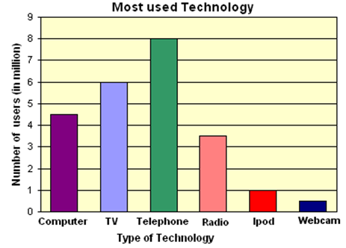

- **Pie Charts:**

Use different colors and labels to distinguish categories, like a pie chart representing the market share of different smartphone brands.

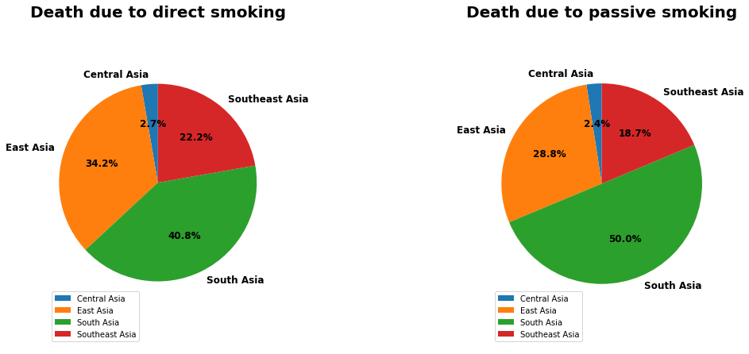

**2. Numerical Data**

-Line Charts: Line charts can employ smooth lines and markers to depict trends over time or across different variables, such as a stock price chart.

- Scatter Plots: These can use various marker shapes and colors to show relationships between two numeric variables, like a scatter plot depicting the correlation between height and weight.

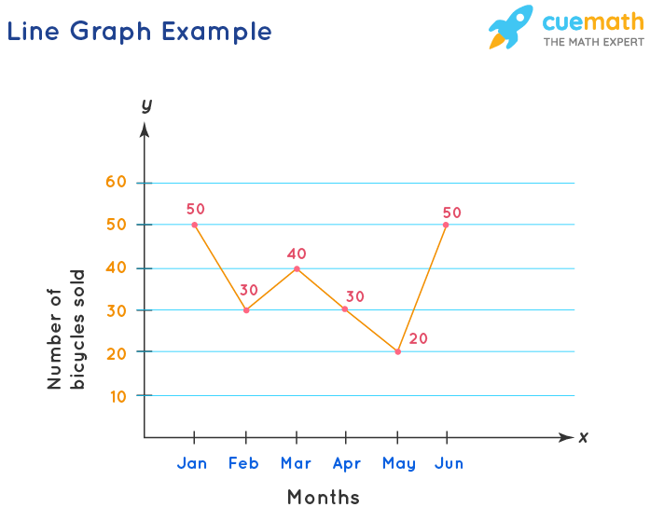

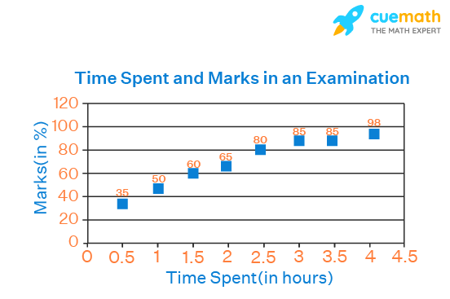

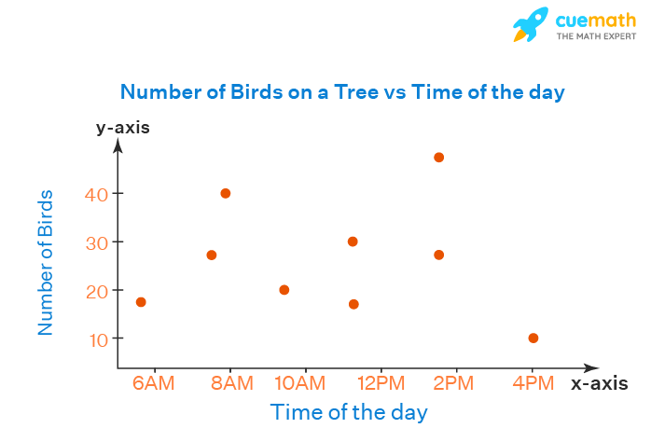

**3. Time Series Data:**

- Area Charts: Aesthetically pleasing area charts can use gradient fills to represent cumulative data over time, such as a chart showing temperature changes throughout the day.

- Gantt Charts: These can employ different colors and labels to represent tasks and their durations in a project timeline.

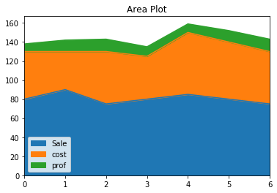

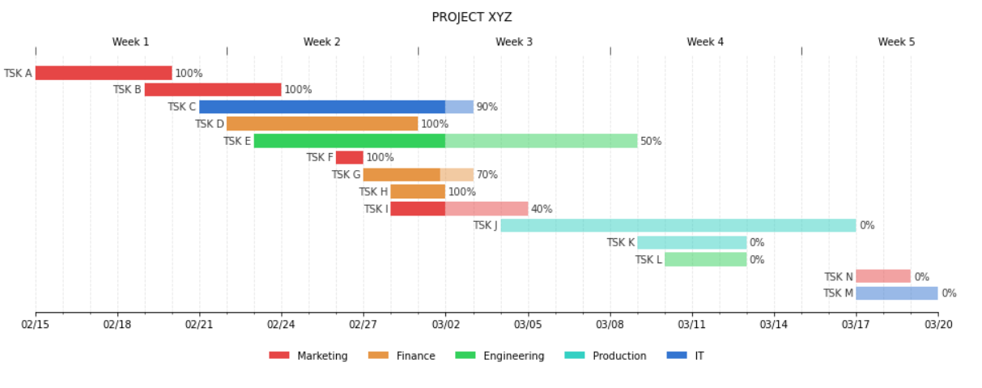

**4. Hierarchical Data:**

-Tree Maps: Tree maps can use color gradients and nested rectangles to visually represent hierarchical data, such as a visualization of file storage usage on a computer.

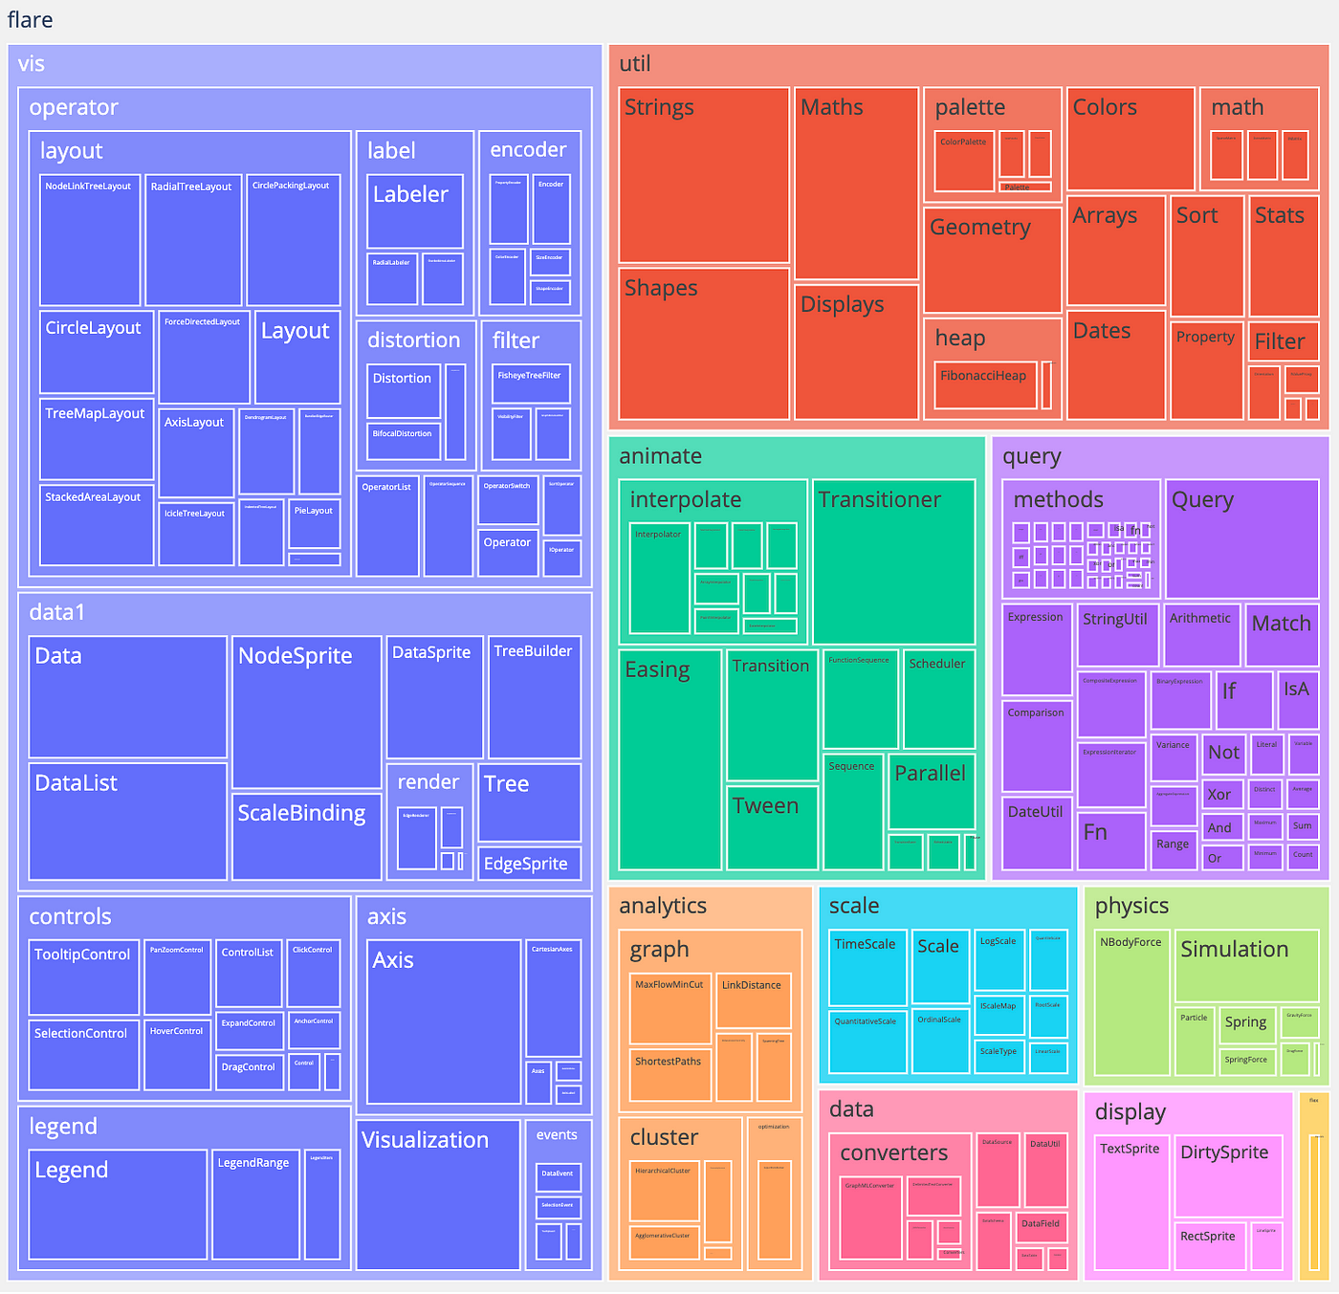

**5. Geospatial Data:**

Choropleth Maps: Aesthetics in choropleth maps involve color scales and legends to convey data variations across geographical regions, like a map showing population density by state.

Bubble Maps: These can use different-sized and colored bubbles to represent data points with geospatial coordinates, such as a map showing the locations and sales figures of retail stores.

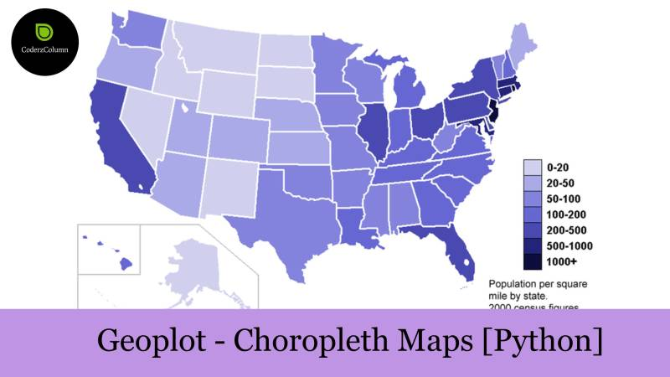

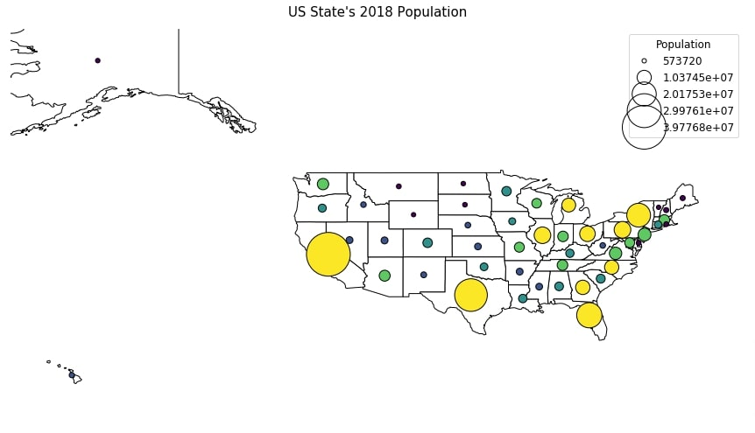

**6. Text Data:**

Word Clouds: Aesthetically pleasing word clouds can use varying font sizes and colors to highlight the frequency of words in a text dataset, like a word cloud of customer reviews where important keywords stand out.



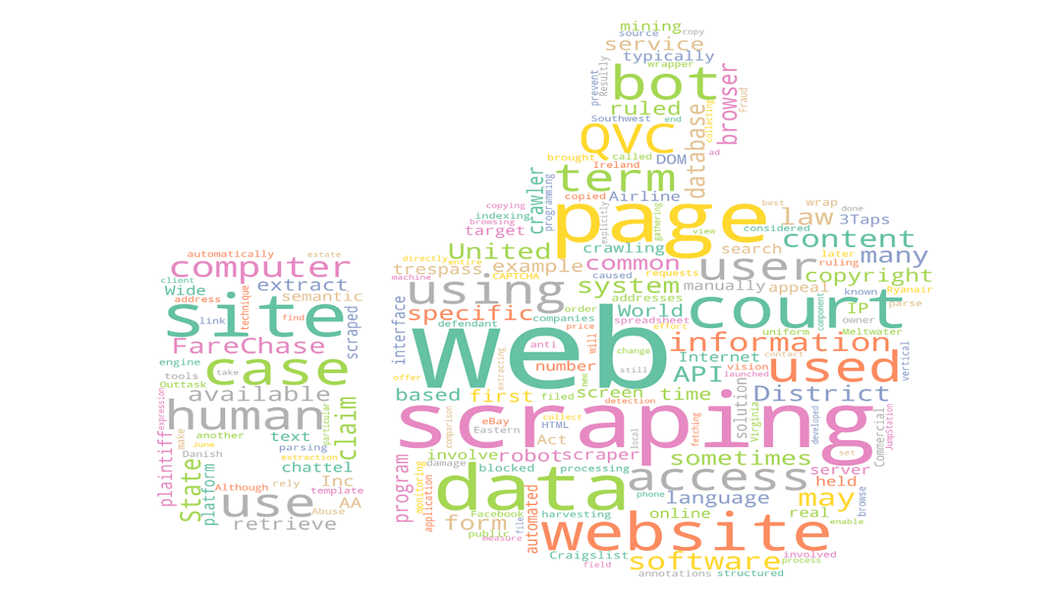

**7. Network Data:**

Graph Visualizations: Aesthetics in network visualizations include node and edge styling, layout choices, and color-coding to represent relationships and attributes in a network, such as a social network graph.

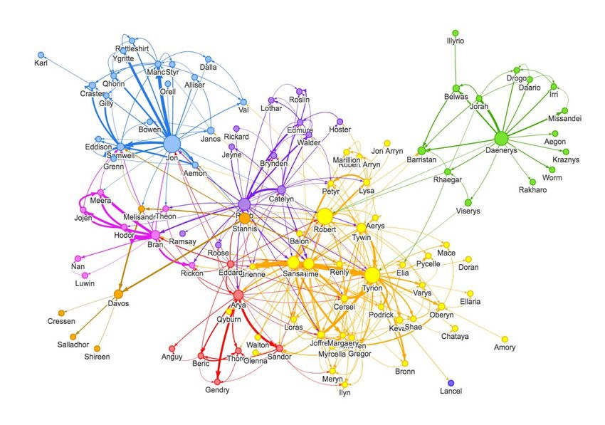

Remember that the choice of aesthetics should be guided by the nature of the data and the goals of the visualization. Effective data visualization not only looks appealing but also communicates insights clearly and accurately to the audience.

**SCALES MAP DATA VALUES ONTO AESTHETICS**

Scaling map data values onto aesthetics is a common practice in data visualization and graphic design. It involves using data values to determine the visual properties of graphical elements, such as the size, color, position, or shape of elements in a chart or map. This helps convey information effectively and make data-driven graphics more interpretable. Here are some common examples of how data values can be scaled onto aesthetics:

**1. Color Mapping**

- Example: In a heat map showing global temperature variations, you can map temperature values to colors, where cooler temperatures are represented by shades of blue and warmer temperatures by shades of red. This makes it easy to visually identify temperature patterns.

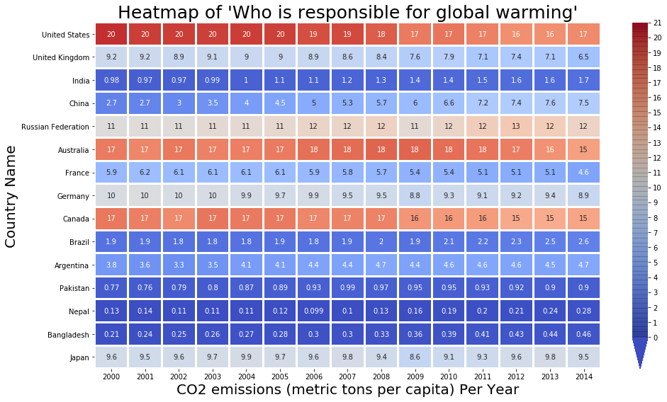

**2. Size Scaling**

- Example: In a bubble chart representing population data for different cities, you can scale the size of bubbles according to the population size. Larger bubbles represent cities with higher populations, making it visually apparent which cities are more populous.



**3. Position Mapping**

- Example: A scatter plot showing the relationship between years of education and income can position data points horizontally based on education level and vertically based on income. This shows how these two variables correlate.

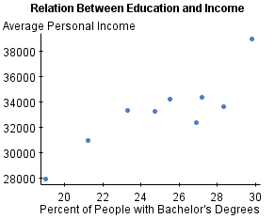

**4. Opacity Mapping**

- Example: On a geographical map displaying air quality data, you can vary the opacity of map layers based on air pollution levels. High pollution areas are more opaque, while low pollution areas are more transparent, allowing viewers to see trends and hotspots.

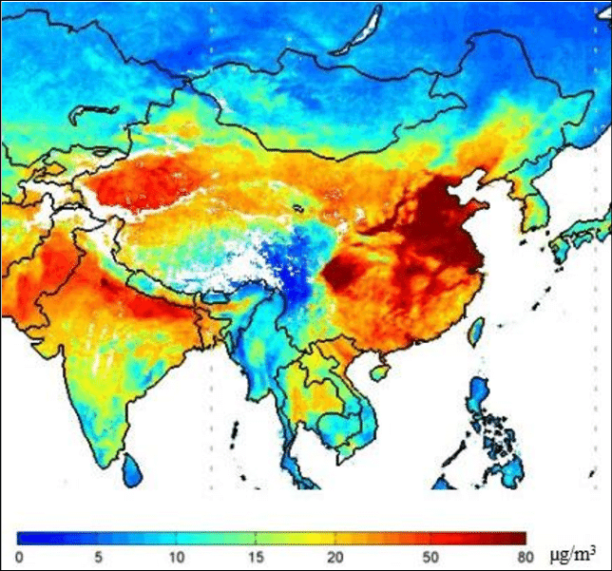

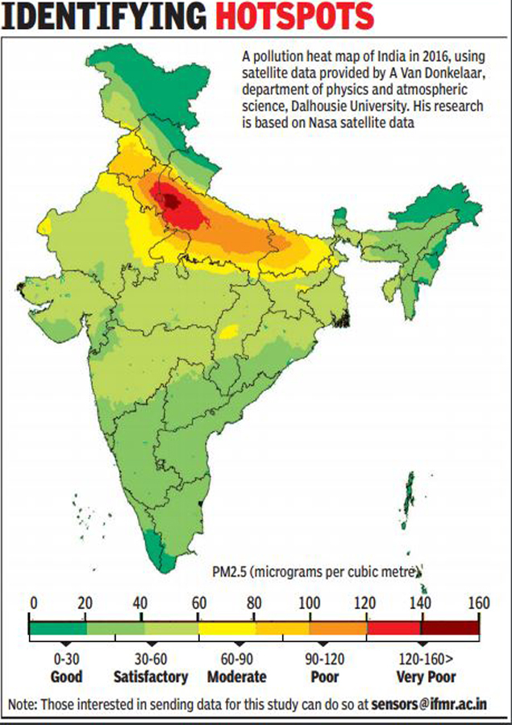

**5. Shape Mapping**

- Example: In a chart comparing the types of products sold in a store, you can use different shapes (e.g., circles, triangles, squares) to represent different product categories. Each shape's size can be proportional to the sales volume for that category.

**6. Texture Mapping**

- Example: When visualizing land use in an urban area, you can use different textures (e.g., hatching, dots, stripes) to represent different land-use categories, such as residential, commercial, or industrial zones.

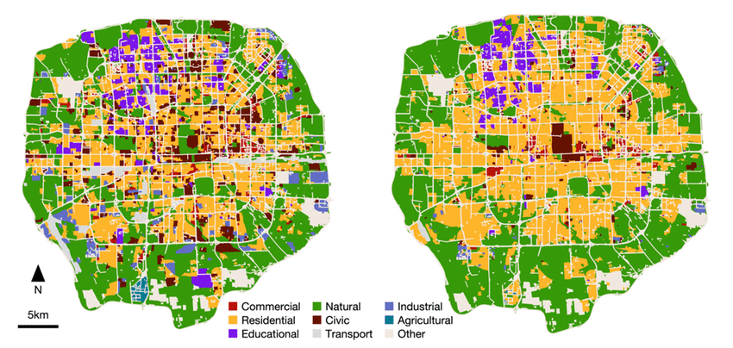

**7. Line Thickness Mapping**

- Example: In a time series chart showing stock market data, you can vary the thickness of lines representing different stocks based on their trading volume. Thicker lines indicate higher trading volume, helping traders identify liquid stocks.

**8. Label Size Mapping**

- Example: When creating a word cloud from a dataset of popular keywords, you can size words based on their frequency. More frequent words appear larger, making the most common terms stand out.

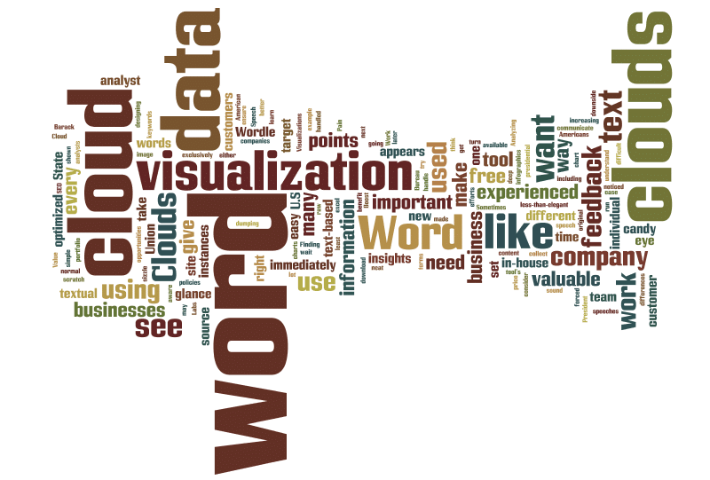

**9. Time Mapping**

- Example: In an animated map displaying population growth over decades, you can change the position and size of population dots over time, showing how populations have shifted and increased over the years.

In all these examples, the data values are transformed into visual or auditory aesthetics, enhancing the communication of information and insights. The choice of which aesthetic to map the data onto depends on the nature of the data and the message you want to convey.

**BAR PLOTS**

Creating bar plots is a common data visualization task in data analysis and visualization. Bar plots are used to display categorical data with rectangular bars, where the length of each bar represents the quantity or frequency of a category. Here, I'll provide examples and code for creating bar plots using Python and the popular data visualization library, Matplotlib.

**Example 1: Simple Bar Plot**

Let's start with a basic example of a bar plot using Matplotlib. We'll create a bar plot to visualize the sales data of different products.

**import matplotlib.pyplot as plt**

**# Sample data**

**products = ['Product A', 'Product B', 'Product C', 'Product D']**

**sales = [1200, 1800, 900, 1500]**

**# Create a bar plot**

**plt.bar(products, sales)**

**# Adding labels and title**

**plt.xlabel('Products')**

**plt.ylabel('Sales')**

**plt.title('Product Sales')**

**# Show the plot**

**plt.show()**

This code will generate a simple bar plot displaying the sales of different products.



**Example 2: Grouped Bar Plot**

A grouped bar plot is used to compare data across different groups or categories. Here, we'll visualize the sales of two different years for each product.

**import matplotlib.pyplot as plt**

**import numpy as np**

**# Sample data**

**products = ['Product A', 'Product B', 'Product C', 'Product D']**

**year_1_sales = [1200, 1800, 900, 1500]**

**year_2_sales = [1300, 1600, 950, 1400]**

**width = 0.35 # Width of the bars**

**# Create x-axis positions for the bars**

**x = np.arange(len(products))**

**# Create grouped bar plot**

**plt.bar(x - width/2, year_1_sales, width, label='Year 1')**

**plt.bar(x + width/2, year_2_sales, width, label='Year 2')**

**# Adding labels and title**

**plt.xlabel('Products')**

**plt.ylabel('Sales')**

**plt.title('Product Sales by Year')**

**plt.xticks(x, products)**

**plt.legend()**

**# Show the plot**

**plt.show()**

This code will generate a grouped bar plot showing the sales of each product for two different years.



**Example 3: Horizontal Bar Plot**

You can also create horizontal bar plots, which are useful when you have long category names or want to emphasize the values along the y-axis. Here's an example:

**import matplotlib.pyplot as plt**

# Sample data

**categories = ['Category 1', 'Category 2', 'Category 3', 'Category 4']**

**values = [25, 40, 30, 55]**

# Create a horizontal bar plot

**plt.barh(categories, values, color='skyblue')**

**# Adding labels and title**

**plt.xlabel('Values')**

**plt.ylabel('Categories')**

**plt.title('Horizontal Bar Plot')**

**# Show the plot**

**plt.show()**

This code will generate a horizontal bar plot displaying the values for different categories.



These are just a few examples of creating bar plots using Matplotlib in Python. Matplotlib offers extensive customization options to tailor the appearance of your plots to your specific needs. You can further explore Matplotlib's documentation for more advanced customization and features.

**GROUPED AND STACKED BARS**

Grouped and stacked bar charts are popular data visualization techniques **used to represent categorical data with multiple series.** In **a grouped bar chart, multiple bars are grouped together for each category**, while **in a stacked bar chart, the bars are stacked on top of each other, with each bar representing a different category**.

**import matplotlib.pyplot as plt**

**import numpy as np**

**species = ("Adelie", "Chinstrap", "Gentoo")**

**penguin_means = {**

**'Bill Depth': (18.35, 18.43, 14.98),**

**'Bill Length': (38.79, 48.83, 47.50),**

**'Flipper Length': (189.95, 195.82, 217.19),**

**}**

**x = np.arange(len(species)) # the label locations**

**width = 0.25 # the width of the bars**

**multiplier = 0**

**fig, ax = plt.subplots(layout='constrained')**

**for attribute, measurement in penguin_means. items():**

**offset = width * multiplier**

**rects = ax.bar(x + offset, measurement, width, label=attribute)**

**ax.bar_label(rects, padding=3)**

**multiplier += 1**

**# Add some text for labels, title and custom x-axis tick labels, etc.**

**ax.set_ylabel('Length (mm)')**

**ax.set_title('Penguin attributes by species')**

**ax.set_xticks(x + width, species)**

**ax.legend(loc='upper left', ncols=3)**

**ax.set_ylim(0, 250)**

**plt.show()**

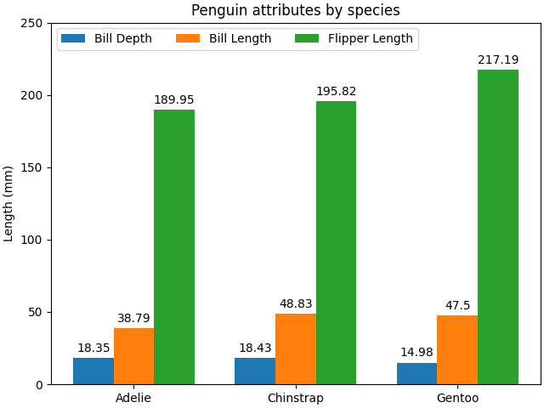

Examples of both grouped and stacked bar charts in Python using the Matplotlib library. Make sure you have Matplotlib installed, or you can install it using `pip install matplotlib` if needed.

**Grouped Bar Chart Example:**

In this example, we'll create a grouped bar chart to compare the scores of two teams (Team A and Team B) for different subjects.

**import matplotlib.pyplot as plt**

**import numpy as np**

**# Sample data**

**subjects = ['Math', 'Science', 'History', 'English']**

**team_a_scores = [85, 78, 92, 88]**

**team_b_scores = [90, 82, 88, 95]**

**# Define the width of each bar group**

**bar_width = 0.35**

**index = np.arange(len(subjects))**

**# Create the grouped bar chart**

**plt.bar(index - bar_width/2, team_a_scores, bar_width, label='Team A')**

**plt.bar(index + bar_width/2, team_b_scores, bar_width, label='Team B')**

**# Customize the chart**

**plt.xlabel('Subjects')**

**plt.ylabel('Scores')**

**plt.title('Team A vs. Team B Scores by Subject')**

**plt.xticks(index, subjects)**

**plt.legend()**

**# Display the chart**

**plt.show()**



**Stacked Bar Chart Example:**

**import matplotlib.pyplot as plt**

**import numpy as np**

**species = (**

**"Adelie\n $\\mu=$3700.66g",**

**"Chinstrap\n $\\mu=$3733.09g",**

**"Gentoo\n $\\mu=5076.02g$",**

**)**

**weight_counts = {**

**"Below": np.array([70, 31, 58]),**

**"Above": np.array([82, 37, 66]),**

**}**

**width = 0.5**

**fig, ax = plt.subplots()**

**bottom = np.zeros(3)**

**for boolean, weight_count in weight_counts.items():**

**p = ax.bar(species, weight_count, width, label=boolean, bottom=bottom)**

**bottom += weight_count**

**ax.set_title("Number of penguins with above average body mass")**

**ax.legend(loc="upper right")**

**plt.show()**

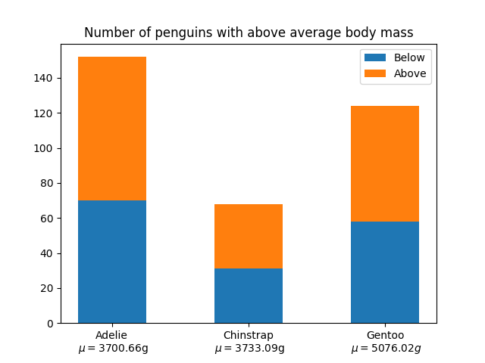

In this example, we'll create a stacked bar chart to show the breakdown of monthly expenses for two different individuals (Person 1 and Person 2).

**import matplotlib.pyplot as plt**

**# Sample data**

**months = ['January', 'February', 'March', 'April', 'May']**

**person1_expenses = [2000, 2200, 1800, 2100, 2400]**

**person2_expenses = [1500, 1700, 1600, 1900, 2100]**

**# Create the stacked bar chart**

**plt.bar(months, person1_expenses, label='Person 1')**

**plt.bar(months, person2_expenses, bottom=person1_expenses, label='Person 2')**

**# Customize the chart**

**plt.xlabel('Months')**

**plt.ylabel('Expenses')**

**plt.title('Monthly Expenses Comparison')**

**plt.legend()**

**# Display the chart**

**plt.show()**



In the stacked bar chart example, the `bottom` parameter in the second `plt.bar()` call specifies that the bars for Person 2 should be stacked on top of Person 1's bars. This creates a stacked effect to represent the combined expenses for each month.

**DOT PLOTS AND HEAT MAPS**

# **Dot Plot**

A dot plot is used to encode data in a dot or small circle. The dot plot is shown on a number line that displays the distribution of numerical variables where a value is defined by each dot.

## What is Dot Plot?

A dot plot is used to represent any [data](https://www.cuemath.com/data/) in the form of dots or small circles. It is similar to a simplified [histogram](https://www.cuemath.com/data/histograms/) or a [bar graph](https://www.cuemath.com/data/bar-graphs/) as the height of the bar formed with dots represents the numerical value of each variable.

Dot plots are used to represent small amounts of data. For example, a dot plot can be used to collect the vaccination report of newborns in an area, which is represented in the following table.

| COLONY | A | B | C | D |
| --- | --- | --- | --- | --- |
| NUMBER OF BABIES VACCINATED | 7 | 3 | 5 | 1 |

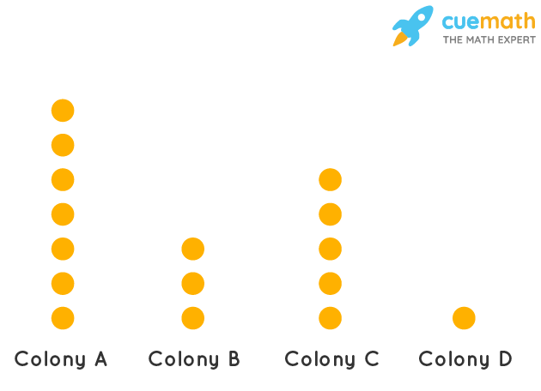

**Types of Dot Plots:**



Here are some common types of dot plots with examples:

**Simple Dot Plot:**

A basic dot plot consists of dots arranged in a single horizontal or vertical line. Each dot represents one data point. It is useful for displaying the distribution of a single dataset.

**Stacked Dot Plot:**

In a stacked dot plot, dots are stacked on top of each other for each unique data value. Useful for comparing the distribution of two or more datasets.

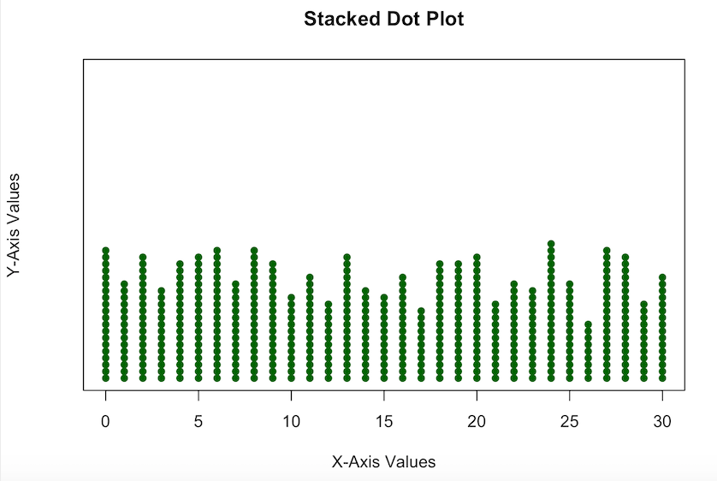

**Cleveland Dot Plot:**

Introduced by William S. Cleveland, this variation of the dot plot uses lines to connect dots with the same value. It emphasizes the distribution more clearly.

**Quantile Dot Plot:**

A quantile dot plot shows quantiles of a dataset, like the median, quartiles, and outliers. Dots are placed at the values of these quantiles.

**Grouped Dot Plot:**

A grouped dot plot arranges dots in groups based on categories or groups. Useful for comparing distributions across categories.

**Diverging Dot Plot:**

Diverging dot plots are used to show the distribution of data around a central point or mean.

Dots are arranged on both sides of the central point.

How to create dot plots and heat maps in Python using popular libraries like Matplotlib and Seaborn. First, make sure you have these libraries installed:

**pip install matplotlib seaborn**

**Examples for both dot plots and heat maps:**

**Dot Plot Example:**

A dot plot is used to visualize the distribution of a single categorical variable. We'll use the `matplotlib` library for this example.

**import matplotlib.pyplot as plt**

**# Sample data**

**categories = ['A', 'B', 'C', 'D', 'E']**

**values = [5, 10, 8, 12, 7]**

**# Create a dot plot**

**plt.figure(figsize=(8, 4))**

**plt.plot(values, categories, 'ro', markersize=10) # 'ro' specifies red circles**

**plt.xlabel('Frequency')**

**plt.title('Dot Plot Example')**

**plt.grid(axis='x', linestyle='--', alpha=0.6)**

**plt.show()**

In this example, we create a dot plot to visualize the frequencies of different categories (A, B, C, D, E).



**Heat Map Example:**

A heatmap is used to display a matrix-like dataset where values are represented by colors. We'll use the `seaborn` library to create a heatmap.

**import seaborn as sns**

**import matplotlib.pyplot as plt**

**# Sample data**

**data = [**

**[0.2, 0.5, 0.8, 0.3],**

**[0.7, 0.1, 0.6, 0.4],**

**[0.9, 0.2, 0.5, 0.7],**

**[0.3, 0.8, 0.2, 0.6]**

**]**

**# Create a heatmap**

**plt.figure(figsize=(8, 6))**

**sns.heatmap(data, annot=True, cmap="YlGnBu", fmt=".2f", linewidths=.5)**

**plt.xlabel('X-axis')**

**plt.ylabel('Y-axis')**

**plt.title('Heat Map Example')**

**plt.show()**



In this example, we create a heatmap using `seaborn` to visualize a 2D matrix of data. The `cmap` parameter specifies the color map, and `fmt` specifies the format for displaying values in the cells.

You can modify these examples to suit your specific data and styling preferences. These are basic examples to get you started with dot plots and heat maps in Python.

**EXPLORATION OF VISUALIZATION TOOLS**

Visualization tools are essential for transforming data into meaningful insights, making complex information more accessible, and aiding decision-making processes. There are various visualization tools available, each catering to different needs and preferences. Let's explore some popular visualization tools and provide examples of their use cases:

**Tableau:**

- Use Case: Business Intelligence and Data Analytics.

- Example: Creating interactive dashboards to analyze sales data, visualize customer demographics, and track key performance indicators (KPIs).

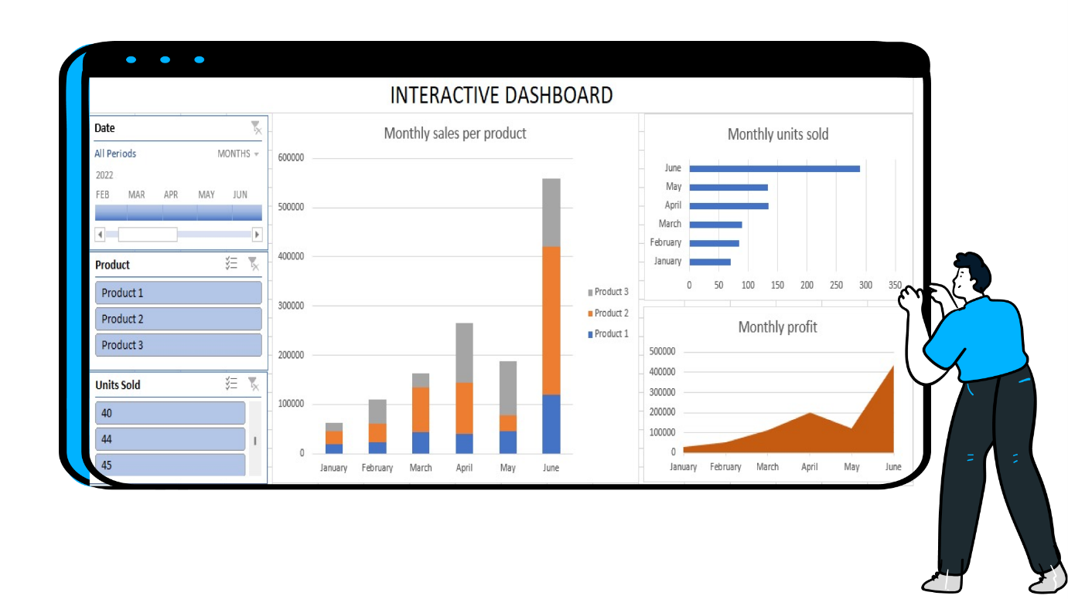

**Power BI:**

- Use Case: Data reporting and visualization for Microsoft users.

- Example: Building reports to monitor financial data, sales trends, and inventory levels.

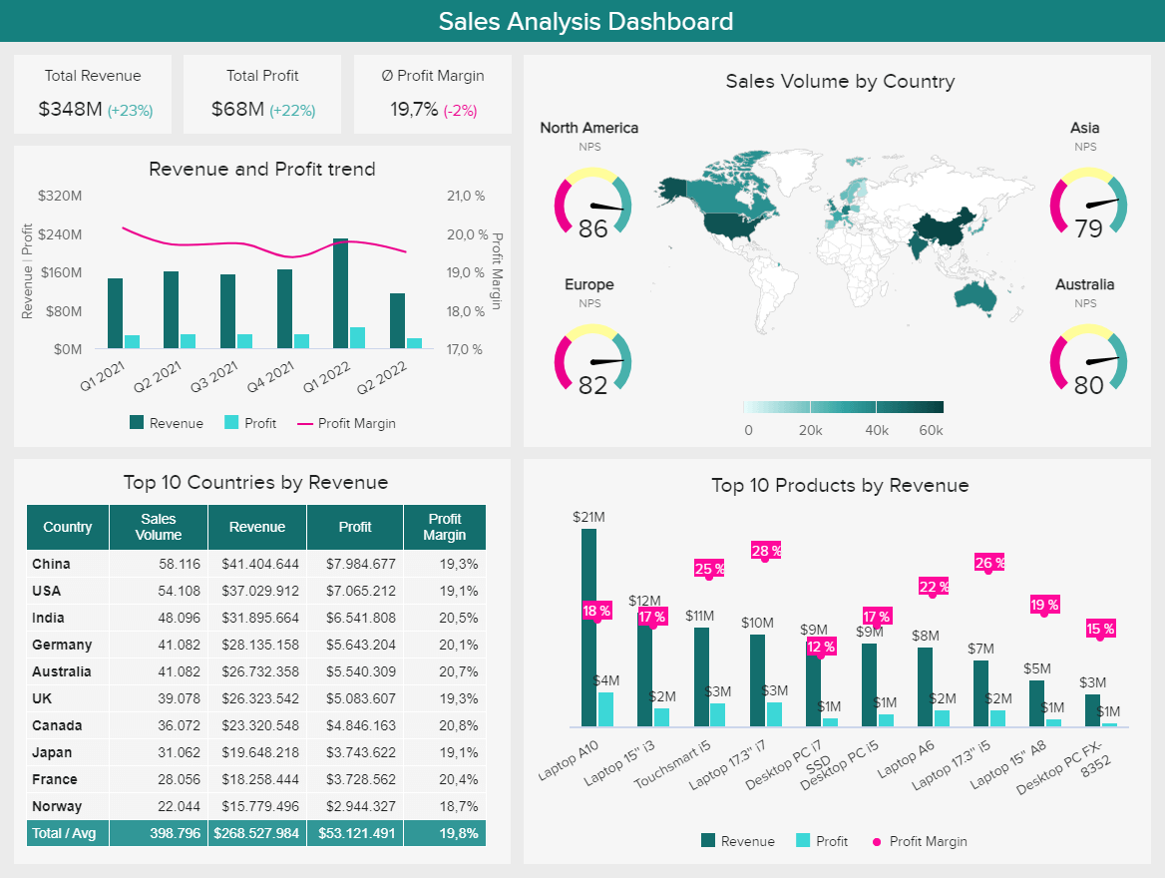

**QlikView/Qlik Sense:**

- Use Case: Data discovery and self-service analytics.

- Example: Exploring healthcare data to identify patient outcomes, treatment effectiveness, and cost-saving opportunities.

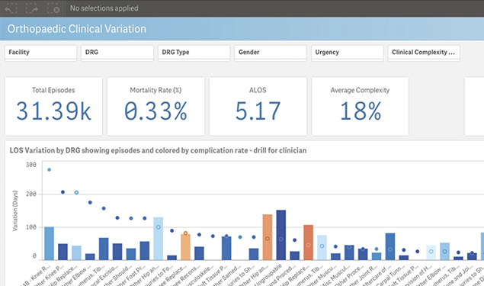

**Google Data Studio:**

- Use Case: Data visualization and reporting using Google's ecosystem.

- Example: Creating marketing performance reports with data from Google Analytics, Google Ads, and other sources.

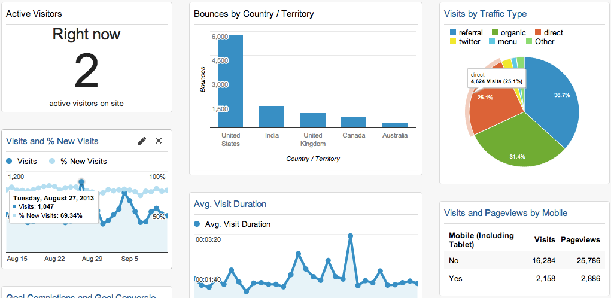

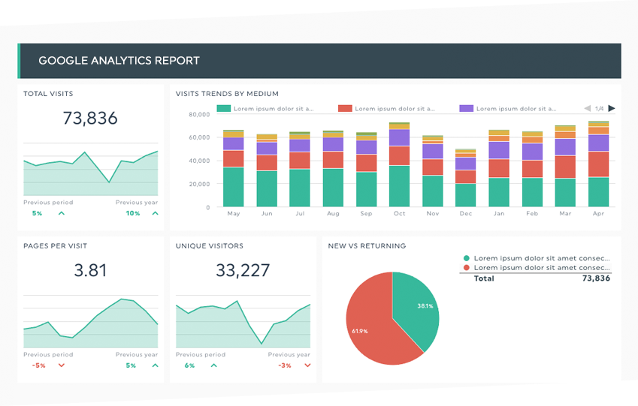

**Plotly:**

- Use Case: Interactive data visualization in Python and JavaScript.

- Example: Developing a web-based dashboard to display real-time stock market data with interactive candlestick charts.

**D3.js (Data-Driven Documents):**

- Use Case: Custom and intricate data visualizations.

- Example: Building a data-driven map to visualize population density by region with interactive zoom and pan features.

**Matplotlib (Python):**

- Use Case: Basic to advanced static visualizations in Python.

- Example: Creating line charts to show temperature trends over time for various cities.

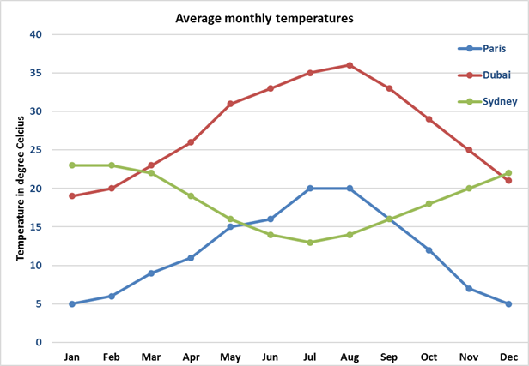

**ggplot2 (R):**

- Use Case: Data visualization in R, ideal for statistical graphics.

- Example: Plotting a scatterplot matrix to explore correlations between multiple variables.

**Canva:**

- Use Case: Graphic design and simple data visualizations.

- Example: Creating social media graphics with embedded charts to showcase monthly engagement metrics.

**CARTO:**

- Use Case: Spatial data visualization and mapping.

- Example: Visualizing geographic data, such as store locations and sales territories, on an interactive map.

**Google Charts:**

- Use Case: Easily embeddable charts for web applications.

- Example: Adding a bar chart to a website to display user ratings and reviews.

**Geospatial Tools (ArcGIS, Mapbox):**

- Use Case: Advanced geospatial analysis and mapping.

- Example: Creating a custom map with population density data and overlaying it with environmental factors.

**Excel (Yes, it's a basic tool but often used for visualization):**

- Use Case: Simple data visualization and charting.

- Example: Building a pie chart to represent the market share of different products.

When selecting a visualization tool, consider your specific requirements, data sources, the level of interactivity needed, and your familiarity with programming languages or software. Many tools offer free versions or trials, allowing you to experiment and find the best fit for your visualization needs.